GhostNet Project
Deliverable 1

Contents
Part I — Security Management and Planning
Part II — Threat Modeling Document
Part III — Risk Management Plan

Secure Software Design and Development
Ummama Khan · Sofia Faisal · Momna Jamil

PART I
Security Management and Planning

Security Management and Planning

1. Security Management Overview

1.1 Purpose of Security Management
Security management within the GhostNet project focuses on organizing and coordinating security-related activities throughout the system's development and testing process. Since the project is designed to demonstrate both insecure and secure software implementations, proper management is required to ensure that vulnerabilities are introduced, analyzed, and addressed in a structured and controlled manner.

1.2 Integration of Security into Development
The security management process ensures that security considerations remain integrated with the development process rather than being treated as an isolated activity. This approach allows the project to reflect real-world software development environments where security is continuously monitored, evaluated, and improved during system development.

1.3 Objectives of Security Management
The primary objective of security management in this project is to maintain an organized framework for implementing, testing, documenting, and improving security mechanisms while ensuring that all experimentation with vulnerabilities is conducted responsibly.

2. Security Planning Approach

2.1 Planning Security Activities
Security planning for GhostNet involves defining how security-related activities will be scheduled, coordinated, and executed during the project lifecycle. The planning process ensures that security considerations are incorporated during system design, development, testing, and improvement stages.

2.2 Structured Security Implementation
The planning approach establishes a clear structure for implementing system components, evaluating their security posture, and improving them through secure design practices. The project follows a staged approach where the initial implementation demonstrates insecure design patterns and the later stages introduce improved security mechanisms.

2.3 Project Coordination and Responsibilities
Through structured planning, the project ensures that each development phase contributes to the overall objective of demonstrating secure software design principles. This includes defining development milestones, allocating responsibilities among project members, and ensuring that security testing and documentation are conducted systematically.

3. Development and Implementation Planning

3.1 Phased Development Strategy
The development of GhostNet is planned in a phased manner to allow clear observation of the differences between insecure and secure software implementations.

3.2 Initial System Development
During the initial development stage, the focus will be on building the functional components of the communication system. These components include user authentication mechanisms, messaging capabilities, role-based user structures, and private communication channels. While these features will be operational, certain security mechanisms will intentionally be simplified or omitted to allow controlled demonstration of vulnerabilities.

3.3 Vulnerability Testing Phase
Following the completion of the vulnerable implementation, the system will undergo structured testing and analysis. This stage allows the identification of weaknesses in the system's design and implementation. The findings from this analysis will guide the improvements implemented in the final version of the system.

3.4 Secure System Enhancement
In the final development stage, the system will be enhanced by integrating secure design practices and strengthening previously weak system components. This staged implementation allows the project to demonstrate how secure software design can significantly improve system resilience.

4. Security Documentation and Management

4.1 Importance of Security Documentation
Documentation plays an essential role in the management of security activities within the project. All major development stages, system components, and security observations will be carefully documented throughout the project lifecycle.

4.2 Documentation of Vulnerabilities and Improvements
This documentation will include descriptions of implemented system features, explanations of identified vulnerabilities, and analysis of system behavior during security testing. Maintaining detailed documentation ensures that the development process remains transparent and that the security improvements implemented in later stages can be clearly justified.

4.3 Educational Value of Documentation
The documentation produced during the project will also serve as an educational resource demonstrating how security weaknesses are discovered and addressed within a software system.

5. Security Testing Planning

5.1 Purpose of Security Testing
Security testing is planned as an integral part of the GhostNet project to evaluate how the system behaves when exposed to malicious inputs or unauthorized access attempts. Testing will be conducted after the vulnerable version of the application has been implemented.

5.2 Scope of Testing Activities
The testing process will focus on examining system functionality under conditions that may expose weaknesses in authentication processes, authorization mechanisms, input handling, and session management. These tests will help identify flaws that could allow unauthorized actions or compromise system functionality.

5.3 Analysis of Testing Results
The results of these tests will be recorded and analyzed in order to guide the improvement process implemented during the secure redesign stage.

6. Controlled Security Environment

6.1 Isolated Testing Environment
All development and testing activities associated with the GhostNet project will be conducted within a controlled and isolated environment. The system will operate locally or within a restricted testing environment to ensure that experimental vulnerabilities do not expose external systems to risk.

6.2 Ethical Security Experimentation
The application will not process real user information, and all simulated attacks will be performed strictly within the scope of the academic project. This controlled environment allows the project to demonstrate realistic security scenarios while maintaining compliance with ethical cybersecurity practices.

7. Continuous Improvement of System Security

7.1 Iterative Security Enhancement
An important component of security management within the project is the continuous improvement of system security throughout the development lifecycle. As vulnerabilities are discovered during testing, the system will be progressively refined to eliminate weaknesses and strengthen system components.

7.2 Importance of Proactive Security Management
This iterative improvement process demonstrates how security management contributes to the development of reliable and resilient software systems. By evaluating system weaknesses and implementing improvements in subsequent development stages, the project highlights the importance of proactive security management in modern software development.

PART II
Threat Modeling Document

Threat Modeling Document

1. Scope and Purpose
This document presents the threat model for the GhostNet communication platform, developed as part of the Secure Software Design and Development course.
GhostNet is an educational simulation of an underground hacker communication network designed to demonstrate how insecure software design can lead to real-world vulnerabilities. The system intentionally includes security flaws in Version 1 and later applies secure design principles in Version 2 to demonstrate mitigation strategies.
The objective of this threat model is to:
- Identify potential security threats targeting the GhostNet system
- Analyse possible attack paths and vulnerable components
- Define security controls required for a secure implementation
- Support the risk management and security planning strategy of the project

2. System Overview
GhostNet is a web-based messaging platform simulation where users communicate within private groups known as cells. The platform supports the following user roles:
- Visitor
- Member
- Leader
- Admin
Core system functionality includes:
- User registration and authentication
- Role-Based Access Control (RBAC)
- Private group messaging
- Self-destructing messages
- Security event logging
The system is implemented as a web application running in a controlled environment. To simplify development and maintain a secure test environment, the system does not use a traditional database. Instead, it stores application data using local JSON files or in-memory objects.
This approach allows the project to focus on application-level vulnerabilities such as XSS, IDOR, and Broken Access Control without introducing unnecessary infrastructure complexity.

3. System Architecture
GhostNet follows a layered architecture that separates user interaction, business logic, and storage.

3.1 Architecture Layers
Layer | Component | Responsibility
Client Layer | Web Browser | User interface and request initiation
Presentation Layer | GhostNet Web Application | Handles UI rendering and HTTP requests
Application Layer | Business Logic Modules | Authentication, RBAC, messaging logic
Storage Layer | Local JSON / Memory Objects | Stores users, messages, roles, logs
Infrastructure Layer | Local VM / Development Environment | Secure sandbox for testing

4. System Architecture Diagram

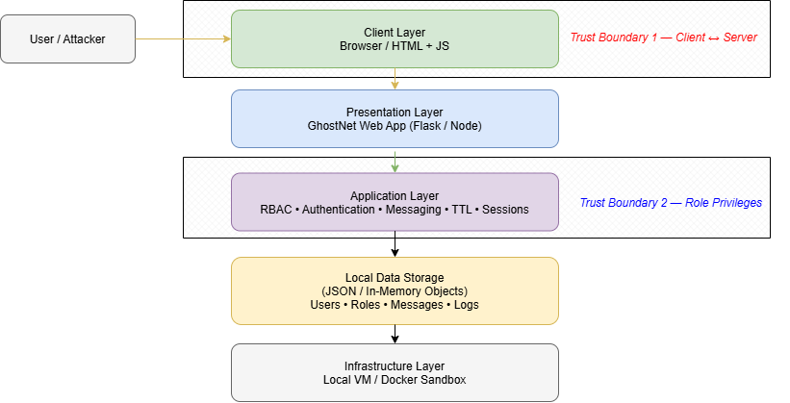

5. Trust Boundaries
Trust boundaries represent points where data crosses from a less trusted area to a more trusted area.

Trust Boundary 1 — Client to Application
Location: User browser → GhostNet web server
Risk:
- XSS injection
- Malicious input
- Session hijacking
Mitigation (V2):
- Input validation
- Output encoding
- Content Security Policy (CSP)

Trust Boundary 2 — Application to Storage
Location: Application logic → JSON/local storage
Risk:
- Data manipulation
- Improper validation
Mitigation (V2):
- Server-side validation
- Strict access control
- Integrity checks

Trust Boundary 3 — Role Privileges
Location: Normal users → Admin functionality
Risk:
- Privilege escalation
- Broken access control
Mitigation (V2):
- Strict RBAC enforcement
- Deny-by-default authorization

6. Data Flow Diagram (DFD)

6.1 DFD Level 0 – System Context

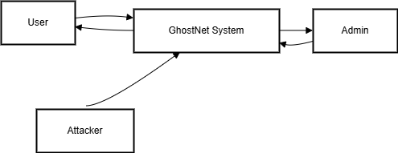
External entities interact with the GhostNet system through login requests, messaging actions, and administrative operations.

6.2 DFD Level 1 – Internal Processes
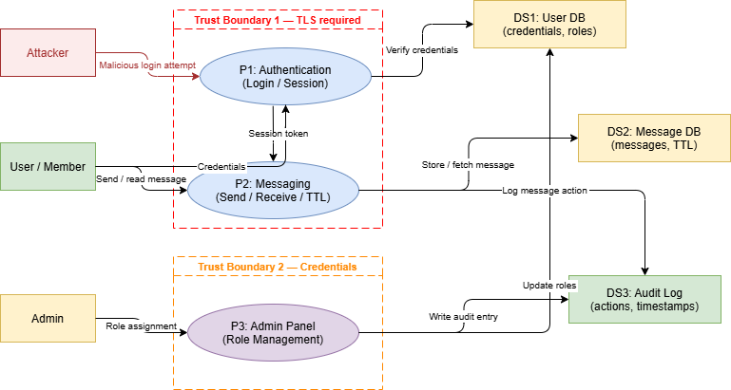

6.3 Stride threat Diagram
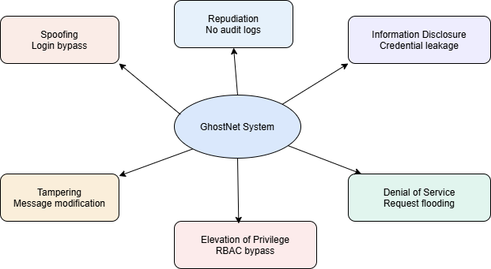

6.4 Attack surface diagram
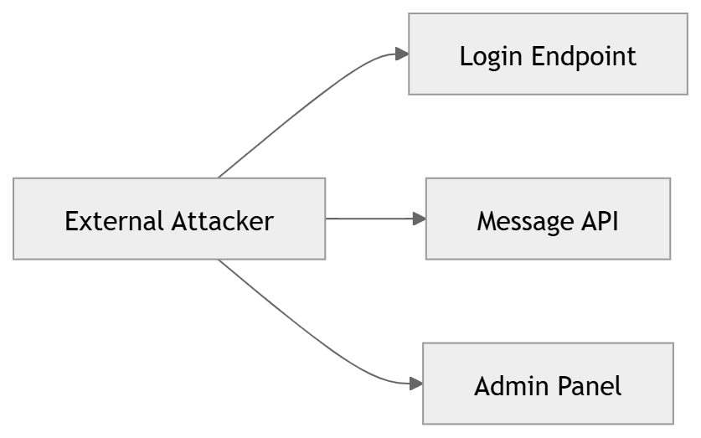

7. STRIDE Threat Analysis
STRIDE | Security Property | Threat | Example
Spoofing | Authentication | Attacker impersonates a user | Login bypass
Tampering | Integrity | Modification of messages | IDOR message manipulation
Repudiation | Non-repudiation | User denies actions | No logging
Information Disclosure | Confidentiality | Data leakage | Verbose errors
Denial of Service | Availability | Service overload | Request flooding
Elevation of Privilege | Authorization | User gains admin rights | Broken RBAC

8. Attack Surface Analysis
Entry Point | Potential Attack | Severity
Login endpoint | SQL-like injection simulation | High
Message API | Stored XSS | Critical
Admin panel | Broken Access Control | Critical
Message TTL logic | Logic flaw | Medium
Error handling | Information disclosure | Medium

9. Security Controls
To mitigate identified threats, the following controls will be implemented in Version 2:
Control | Description
Input Validation | Sanitize all user input
Output Encoding | Prevent XSS attacks
Secure Authentication | Password hashing
RBAC Enforcement | Server-side role verification
Session Security | Secure tokens and expiration
Audit Logging | Record all sensitive actions
Rate Limiting | Prevent brute-force attacks
Error Handling | Hide internal system details

10. OWASP Top 10 Mapping
OWASP Category | Example in GhostNet
A01 Broken Access Control | Role bypass
A02 Cryptographic Failures | Weak password storage
A03 Injection | Login injection
A05 Security Misconfiguration | Debug mode
A07 Authentication Failures | Weak session tokens
A09 Logging Failures | Missing logs

11. Development Phases

Phase 1 — Vulnerable Implementation
Develop GhostNet with intentionally insecure design.
Purpose:
- Demonstrate OWASP vulnerabilities
- Enable controlled exploitation

Phase 2 — Attack Demonstration
Document attacks including:
- Exploitation steps
- Screenshots
- Security impact

Phase 3 — Secure Redesign
Implement security controls including:
- Strong authentication
- RBAC enforcement
- Secure session handling
- Input validation

12. Priority Security Actions
Based on the risk management plan, the following actions are critical:
- Keep vulnerable code isolated in a private repository and local VM.
- Implement strict role validation to prevent privilege escalation.
- Use secure input validation and output encoding to prevent injection attacks.
- Implement audit logging to detect malicious activity.
- Conduct code review and static analysis before submission.

13. Conclusion
The GhostNet threat model identifies key risks associated with the design of a secure communication platform. By analysing threats using the STRIDE methodology and evaluating system architecture, the project highlights how insecure design decisions can introduce vulnerabilities.
The dual-phase approach allows students to first observe the impact of security weaknesses and then apply best practices to mitigate them. This provides practical experience in secure software design, vulnerability analysis, and defensive implementation.

PART III
Risk Management Plan

Risk Management Plan

1. Introduction
This Risk Management Plan identifies, analyses, and prioritises the key risks associated with the GhostNet project — a controlled, educational simulation of an underground hacker communication network developed for the Secure Software Design and Development course. Because the project deliberately implements known OWASP Top 10 vulnerabilities in Version 1 before remediating them in Version 2, it carries inherent technical, ethical, legal, and project-management risks that require proactive governance.
The plan is structured as follows: a risk assessment methodology, a comprehensive risk register covering all identified risks, a visual heat map, and a prioritised mitigation summary.

2. Risk Assessment Methodology
Each risk is rated on two axes using a 1–5 ordinal scale:
- Likelihood (L) — probability that the risk event will occur during the project lifecycle (1 = Rare, 5 = Almost Certain).
- Impact (I) — severity of consequences if the risk materialises (1 = Negligible, 5 = Catastrophic).
- Risk Score = L × I. Scores map to four levels: Critical (≥15), High (9–14), Medium (4–8), Low (<4).

3. Risk Summary
A total of 20 risks were identified across four categories: Technical, Ethical/Legal, Project Management, and Security Process.
Risk Level | Count
Critical (Score ≥ 15) — T-01, E-01, E-02 | 3
High (Score 9–14) — T-02, E-03, P-01, P-02, P-03, P-07 | 6
Medium (Score 4–8) — T-03, T-04, T-05, E-04, P-04, P-05, P-06, S-01, S-02, S-03 | 10
Low (Score < 4) — T-06 | 1
Total | 20

4. Risk Heat Map
The heat map plots each identified risk by Likelihood (rows, 5→1) and Impact (columns, 1→5). Risk IDs appear in each cell.
Likelihood / Impact | I=1 | I=2 | I=3 | I=4 | I=5
L=5 | — | — | — | — | —
L=4 | — | — | — | P-01 | —
L=3 | — | — | T-03, E-04, P-04, P-05, P-06, S-01, S-02 | T-02, P-02, P-03 | T-01
L=2 | — | T-06 | T-04, T-05, S-03 | E-03, P-07 | E-01, E-02
L=1 | — | — | — | — | —

5. Detailed Risk Register

5.1 Technical Risks
ID | Risk Description | L | I | Level | Mitigation Strategy
T-01 | Vulnerable Version 1 code leaks or is deployed outside the controlled lab environment, exposing exploitable functionality. | 3 | 5 | Critical | Store V1 code in a private repository with restricted access; never deploy to public/cloud hosts; use a sandboxed VM.
T-02 | Unintended real vulnerabilities introduced in Version 2, undermining the project's security objectives. | 3 | 4 | High | Conduct peer code review for V2; use SAST tools (Bandit, ESLint); map each fix to OWASP control before submission.
T-03 | Incomplete coverage of OWASP Top 10 vulnerabilities in V1 due to scope underestimation or time constraints. | 3 | 3 | Medium | Map all planned vulnerabilities to OWASP IDs at the design phase; prioritize core categories (A01–A05) early.
T-04 | Self-destruct message logic fails silently, leaving messages accessible beyond intended TTL. | 2 | 3 | Medium | Write unit tests for expiry logic; test boundary conditions; log deletion events for auditability in V2.
T-05 | Database or session data persists between demo environments, causing cross-contamination of test data. | 2 | 3 | Medium | Use separate databases per version/environment; add a reset/seed script; document teardown steps in README.
T-06 | Frontend JavaScript XSS payloads in V1 inadvertently affect the developer's browser outside test scope. | 2 | 2 | Low | Test XSS payloads only in a dedicated browser profile or sandboxed container; use DevTools isolated contexts.

5.2 Ethical & Legal Risks
ID | Risk Description | L | I | Level | Mitigation Strategy
E-01 | Project code or documentation is misused externally to attack real communication platforms. | 2 | 5 | Critical | Include prominent ethical-use disclaimer in all documentation; keep repository private; obtain faculty sign-off before any public sharing.
E-02 | Exploitation demonstrations performed outside the designated sandboxed environment, potentially violating computer misuse laws. | 2 | 5 | Critical | All attack testing must occur on localhost or isolated VM only; document this constraint as a hard policy in the project charter.
E-03 | Submission or demo inadvertently includes real user credentials or PII in test datasets. | 2 | 4 | High | Use synthetic/fake data only; review all exported files before submission; add a pre-submission data audit checklist.
E-04 | Lack of documented ethical guidelines leaves team members uncertain about permissible testing activities. | 3 | 3 | Medium | Draft a one-page ethical-use policy at project start; have all members sign it; reference it in the final report.

5.3 Project Management Risks
ID | Risk Description | L | I | Level | Mitigation Strategy
P-01 | Scope creep from adding extra features delays core deliverables. | 4 | 4 | High | Lock scope after Week 2; use a change-control log; any additions must be approved by the full team and supervisor.
P-02 | Uneven workload distribution among team members leads to bottlenecks or quality inconsistency. | 3 | 4 | High | Assign clear ownership (auth, messaging, security docs) from Day 1; use a shared task board; weekly check-ins.
P-03 | Knowledge silos — only one member understands a critical module — create a single point of failure. | 3 | 4 | High | Require each member to review and summarize at least one section outside their primary area; maintain living design docs.
P-04 | Version control conflicts or accidental overwriting of V1/V2 code on the shared repository. | 3 | 3 | Medium | Use separate Git branches (vulnerable, secure); enforce PR-based merges; tag releases at each milestone.
P-05 | Demonstration environment failure on presentation day (missing dependencies, broken DB connection). | 3 | 3 | Medium | Prepare a recorded backup demo; test in the exact presentation environment at least 48 hours prior; document setup steps.
P-06 | Inadequate documentation of attack demonstrations makes it difficult for evaluators to reproduce findings. | 3 | 3 | Medium | Create step-by-step attack playbooks with screenshots/screen recordings; include expected vs. actual output for each exploit.
P-07 | A team member withdraws or becomes unavailable close to the submission deadline. | 2 | 4 | High | Maintain updated handover notes; cross-train on all critical areas; agree on contingency roles at project kickoff.

5.4 Security Process Risks
ID | Risk Description | L | I | Level | Mitigation Strategy
S-01 | V1 and V2 architecturally diverge so much that comparisons in the final report are unclear or unconvincing. | 3 | 3 | Medium | Keep the same data models and API routes across versions; only change security controls; include side-by-side code diffs in the report.
S-02 | RBAC implementation in V1 is too simplistic to meaningfully demonstrate Broken Access Control (OWASP A01). | 3 | 3 | Medium | Design at least four distinct roles with overlapping privilege scenarios; document specific bypass attack vectors for each.
S-03 | Logging in V2 is insufficient to detect the same attacks demonstrated in V1, weakening the security narrative. | 2 | 3 | Medium | Map each V1 attack to a corresponding V2 log entry; validate detection by replaying V1 payloads against V2 and checking logs.

6. Priority Actions — Top Risks

T-01 & E-01/E-02 — Containment of Vulnerable Code
The single highest-priority action is ensuring V1 code never reaches a public environment. Establish a private repository, use a sandboxed VM for all testing, and document the containment policy in the project charter before writing the first line of code.

P-01 — Scope Lock
After the initial design week, formally freeze the feature list. Any additions require a documented change request approved by all members and the course supervisor.

P-02 & P-03 — Team Resilience
Divide ownership clearly, document all design decisions in a shared document, and conduct brief weekly sync-ups. Each member should be able to describe the full system, not just their module.

T-02 — V2 Security Assurance
Do not assume V2 is secure by design. Schedule a dedicated code-review session using at least one automated tool (e.g., Bandit for Python or ESLint with security plugins for JS) before final submission.

P-07 — Contingency Planning
Agree at kickoff on what happens if a member becomes unavailable. Define minimum viable deliverables and redistribute tasks accordingly.

7. Risk Monitoring & Review
Risk management is not a one-time activity. The team should:
- Review this register at each project milestone (e.g., end of V1, end of attack documentation phase, end of V2).
- Update likelihood/impact scores if circumstances change (e.g., a team member falls behind, a new vulnerability category is added).
- Log any risk event that materialises in a simple incident log, noting the date, risk ID, impact experienced, and response taken.

